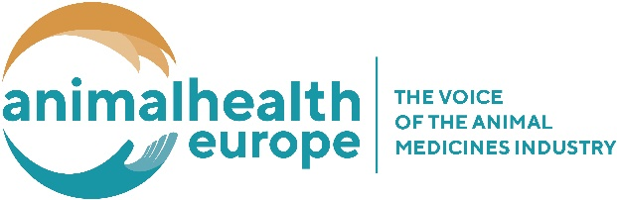
AnimalhealthEurope Event
Registration form - GUEST
7 June 2018, Renaissance Hotel, Brussels, Belgium
Rue du Parnasse, 19 – 1050 Brussels
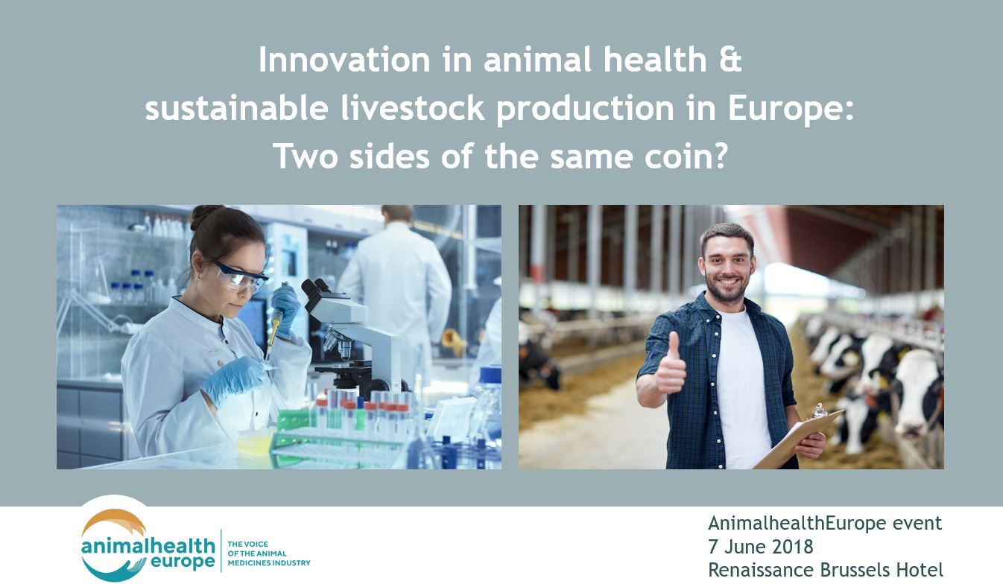

PARTICIPANT DETAILS

-CAPITAL LETTERS PLEASE-

Title: | First Name: |  | Name:
Position:
Organisation/Company:
Invoice address:
Phone: |  | Fax:
E-mail:

PO: | VAT:

Will attend the AnimalhealthEurope event (7 June)

Will attend the AnimalhealthEurope event (7 June) and the dinner (6 June)

Specific dietary requirements: ______________________________________________

PLEASE RETURN TO AnimalhealthEurope by 25 May 2018
Email:c.denorre@animalhealtheurope.eu

