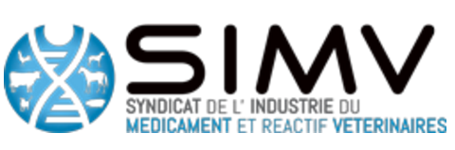
TUESDAY APRIL 4th : 08:30 am - 11:00 am
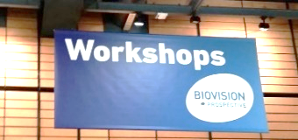

Context
The Antimicrobial Resistance (AMR) is a common threat to disease control throughout the world, and it is a primary concern for human and animal health. Despite public misconceptions, the use of antibiotics in veterinary medicine is very well regulated in Europe. It is important to highlight that antibiotics use as growth factor has been banned since 2006 in Europe and the requirement for their use are at the same level (if not more) as human medicine. In adequation with the human medicine, the prescription of antibiotic is only possible as therapeutic solution and supervised by a veterinarian. However as a full participant in “One Health”, the animal health sector has a key position and is dedicated to the fight the resistance to antibiotics.

In this context, the SIMV participated in the 12th edition of the Biovision event in Lyon under the slogan : From global health to one health and co-organised a workshop about « the fight against antibiotic resistance : diagnostics and therapies of the future in veterinary medicine ». A good success for this workshop that gathered about 15 experts and 15 challengers, around 3 questions :
- Which are the new leads of innovation to fight against antimicrobial resistance ?
- Are these innovations similar in human and veterinary health ?
- Do the public policies and regulation spur or limit these innovations ?

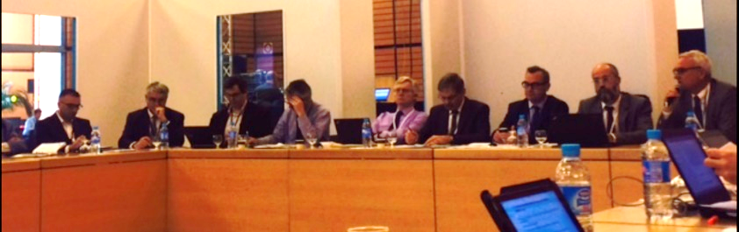
Experts of the workshop composed in part by Jean Regis (Virbac) ; Pascal Raoul (CEVA) ; David Mackay (EMA), Jean-Pierre Orand (ANMV) ; Jacques Lechenet (Mérial/Boehringer) ; Jean-Louis Hunault (SIMV) ; Jean Deleforge (Vétoquinol)

In veterinary medicine solutions exist to fight AMR at different stages of innovation. First of all, the improvement of existing products (antibiotics, vaccines) is an important innovation track in veterinary medicine. For example the reformulation of existing antibiotics can lead to reduce their impact on the digestive flora and the environment and thus their AMR impact. Futhermore innovation paths are directed towards current products that need to validate clinical efficacy, such as the use of probiotics which could help to stimulate or enhance host immunity. Veterinary industries also invest to innovative solutions concept (phage, peptide, …) and all products that can improve sanitary conditions (bacterial vaccines and autovaccines).
About the public policies
One of the primary objective of public policies is to preserve the portfolio of existing products. This workshop illustrates the willingness of the veterinary medicines Agencies to work together and to find solutions to access these innovations. Despite current regulation framework for the veterinary medicinal product (VMP) which is recognized and deemed relevant by the industries, the VMP regulation should be use in smarter way to incentivize innovation. Moreover it is necessary to define better what is an « alternative » to antibiotics or antimicrobials, and define a claim of what is the « reduce use of antibiotic » and the way to assess it. The new EU regulation for VMP will play crucial role for stimulating the competitiveness and the innovation.

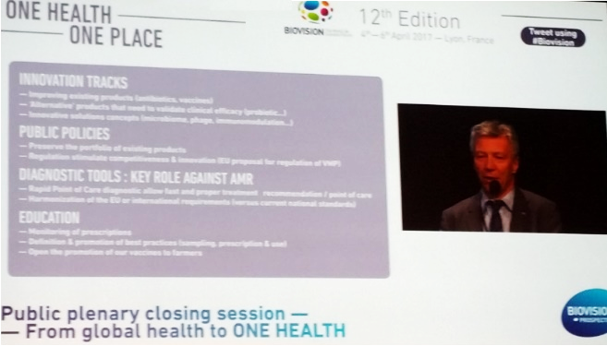
Diagnostic tool : key role against AMR
An adapted diagnostics tools of good quality must be available, to alert on AMR, monitor treatments and even if possible predict risks. In particular, Rapid Point of Care diagnostics allow fast and proper treatment recommendation and it is particularly attractive to hope for pen-side tests, done right in the farm. However, as with any other products, diagnostic tests do not exist in a vacuum; they must be used properly, processing the correct samples and read by educated professionals. An adapted legal framework should allow harmonization of the european requirements (versus current national standards) and would help maintain a high level of quality for veterinary diagnostics.

Education, as well as public understanding and support are key weapons against AMR.
The definition and the promotion of best practices (sampling, prescription and use) is extremely important to use the tools we have correctly, in full understanding of the “One Health” global environment. The veterinary supervision has a major importance in the education and in the monitoring of the prescriptions. Moreover, it is also important to understand that all tools available to improve sanitary conditions in farming, such as vaccination, lead to reduce the risk of apparition and propagation of AMR. It is therefore necessary to be able to advertise vaccination and vaccines toward farmers.
Pascal Raoul (CEVA) SIMV representative during the
public plenary closing session in Biovision

The fight is done in “One Place” the earth, and for “One Health”, animal and human. However, due to the particular constraints in costs, in scope, sometimes in urgencies, the veterinary field deserves its own dedicated framework. We will take from the same toolbox, but different tools and with different ways to use them.

